**Music Genre Classification**

# Definition

## Project Overview:

Automatic music classification/recognition is one such area which is being widely used in many commercial applications also like Shzam, Google Play, Sony Track ID, etc. All these applications have one thing in common that they aim to understand the semantic of the music rather than just curating the metadata out of it. To develop an advanced and intelligent music player there is a large semantic gap between audio signal processing and listeners’ preference. Most of the cloud based music providers use collaborative filtering and sound meta data to recommend the next song to the listeners. But they could not fulfil the gap of listener’s preference i.e genre, mood, lyrics, instrumentation, rhythm, music records time etc.

Thus, we aim to focus the major area for preference of a music listener is genre of music. Music genre classification is one such problem in MIR (Music Information Retrieval) which has been addressed by a lot of signal processing techniques along with standard machine learning algorithms in place. But as we have seen that the traditional signal processing techniques to extract features don’t add much advantage when it comes to typical problems of clustering, classification because we might miss many important features at the time of feature extraction and selection. As Deep Learning has proven its importance in image processing to understand the features from the image pixels. Similarly, we here aim to adopt a similar approach for audio processing.

## Applications

1. Music Tag Recommender (Genre based tagging)
2. Personalized Song Recommender Systems (eg. spotify)
3. Music Teaching Applications to make the students understand, what genre are all about.
4. Automatic Meta Tagging of songs
5. Segmenting the genres in music players or in local PCs for organized storage.
6. Develop song indexing systems using genre as on the key to the hash or node to the btree.

## Problem Statement:

To develop an algorithm that can take a set of songs and assign genre to the particular song. Rather than mining features using traditional Audio Processing Techniques we will use Supervised Deep Learning using Convnets to understand both features and classify them efficiently into different genres eg blues, classical, country, disco, metal, pop, etc.

# Analysis

## Data Exploration:

The dataset used for training is GTZAN dataset, which was used in, “Music genre classification of audio signals”, by G. Tzanetakis and P.Cook. The files are collected from different sources in varied recording conditions to generalize more.

The dataset consists of 100 songs from 10 different genres namely:

1. Blues
2. Classical
3. Country
4. Disco
5. Hiphop
6. Jazz
7. Metal
8. Pop
9. Reggae
10. Rock

Each song if of 30 sec duration and 22050Hz Mono 16-bit in *.au format.

## Exploratory Visualization

1. **Raw Features**:
2. **Specgram**: It is the discrete time fourier transform of the signal using sliding window

Specgram is being calculated in the following manner:

* 1. It splits the signal into overlapping sections and applies the window specified by the window parameter to each section.
  2. It computes the discrete-time Fourier transform of each section with a length nfft FFT to produce an estimate of the short-term frequency content of the signal; these transforms make up the columns of B. specgram zero pads the windowed sections if nfft > length(window), so the quantity (length(window) - noverlap) specifies by how many samples specgram shifts the window.
  3. For real input, specgram truncates the spectrogram to the first nfft/2 + 1 points for nfft even and (nfft + 1)/2 for nfft odd.

1. **Log Power Specgram**: It the power spectral density distribution of the signal using the sliding window.

In the following section we can clearly visualize that based on the genres the waves, dft and the PSD of the signal is different. Thus, in this project we aim to learn such patterns which are being learned through the Machine Learning algorithms clearly.

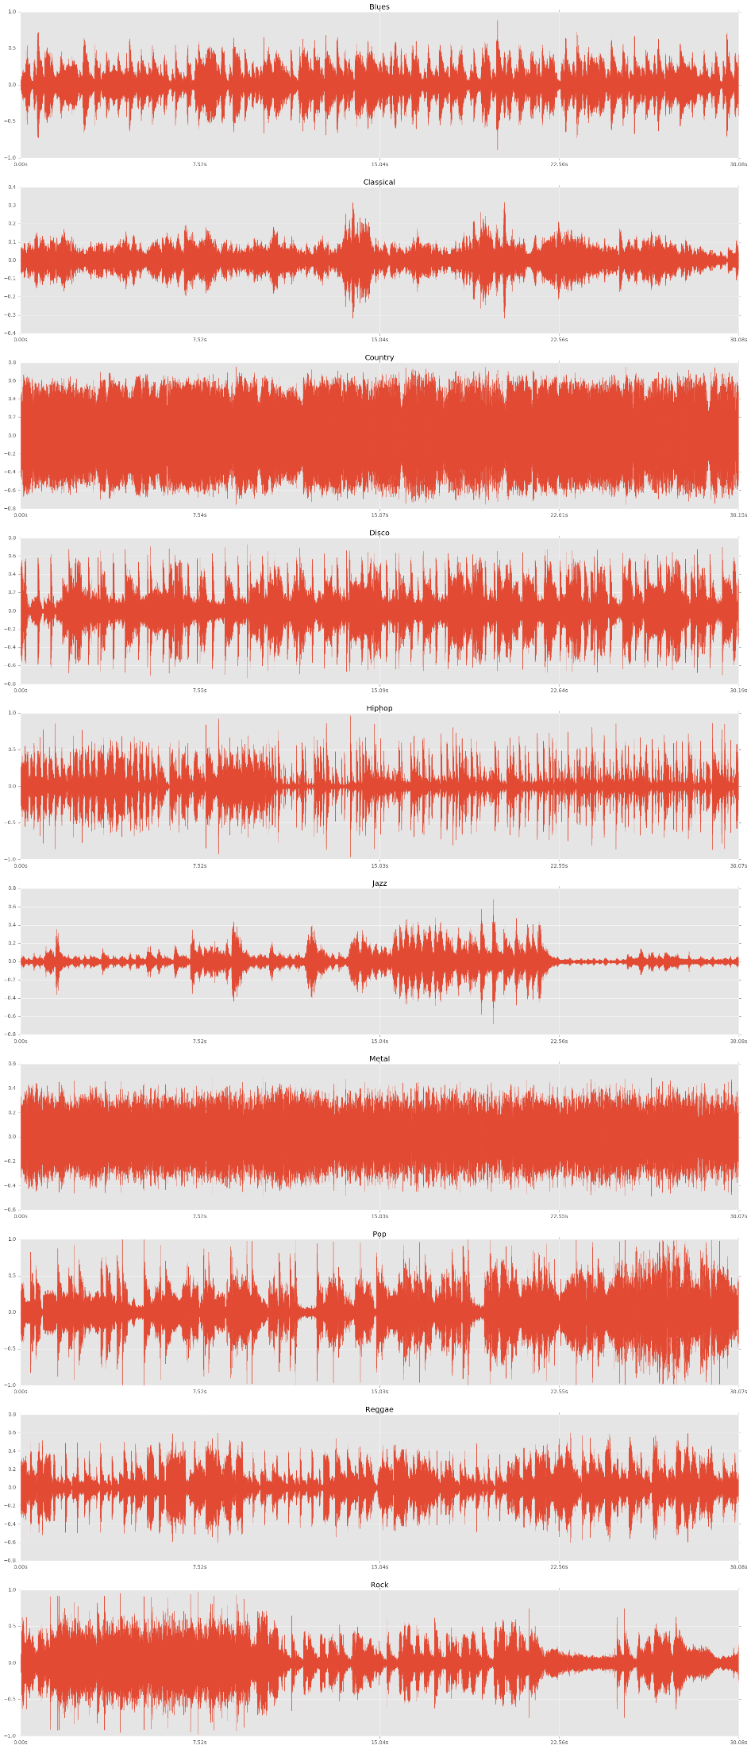

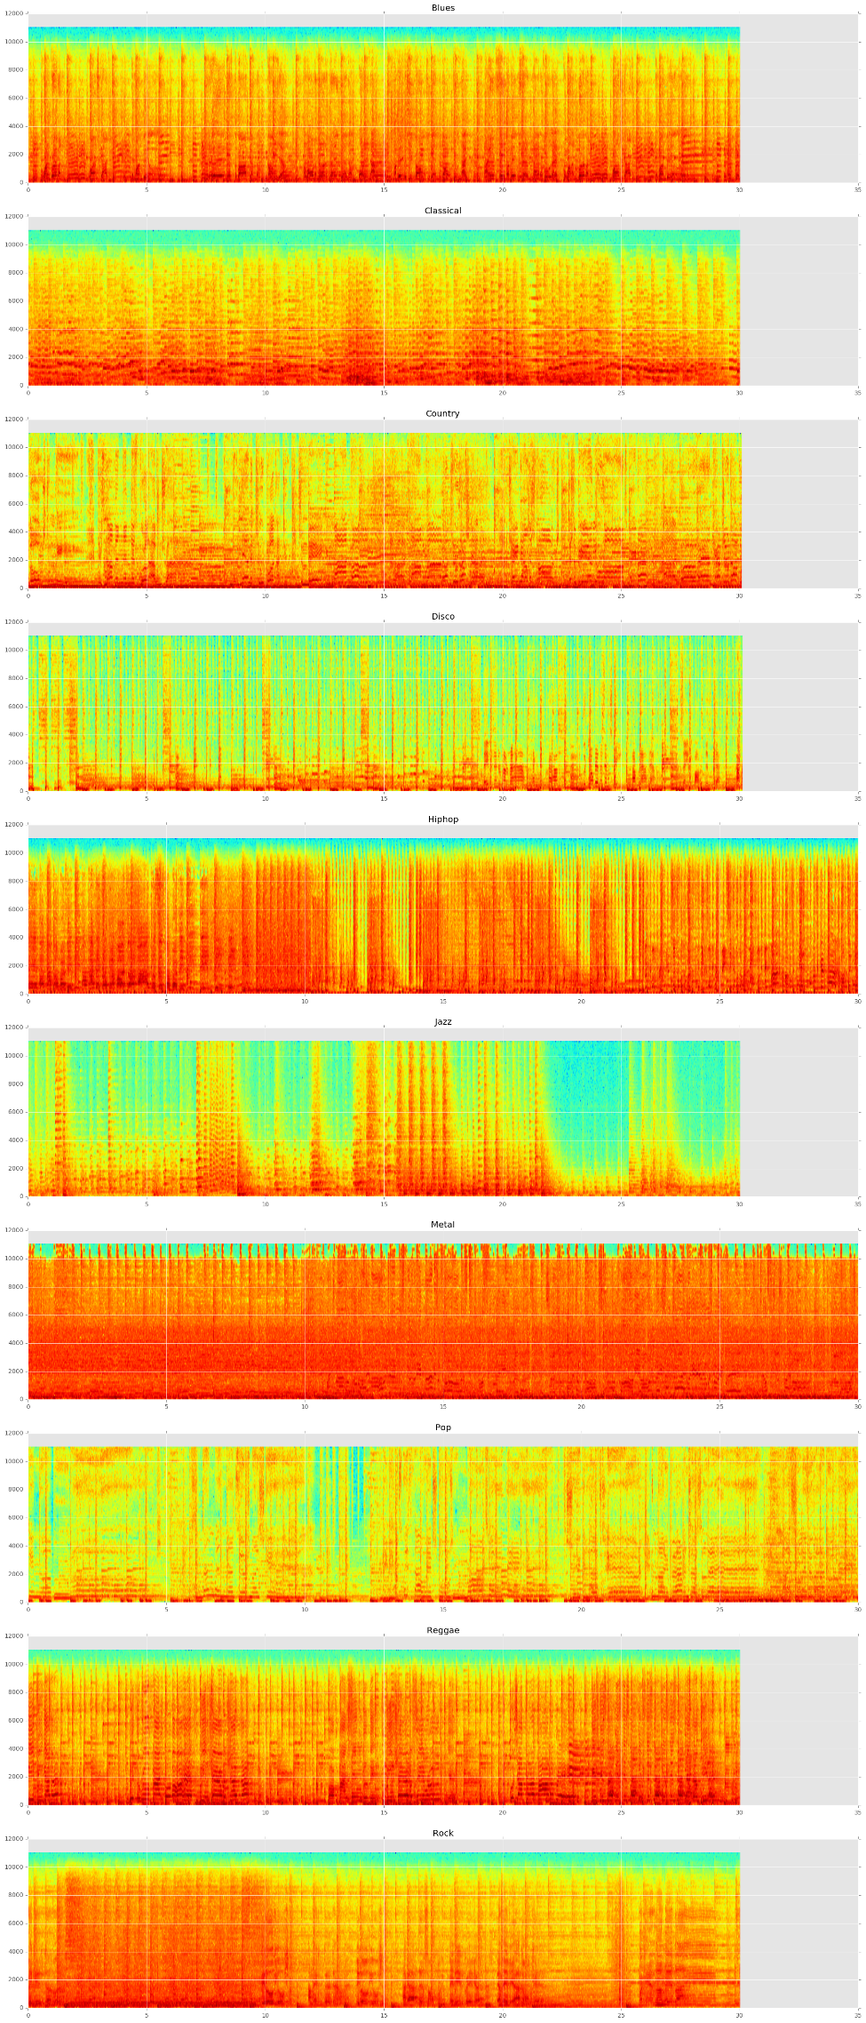

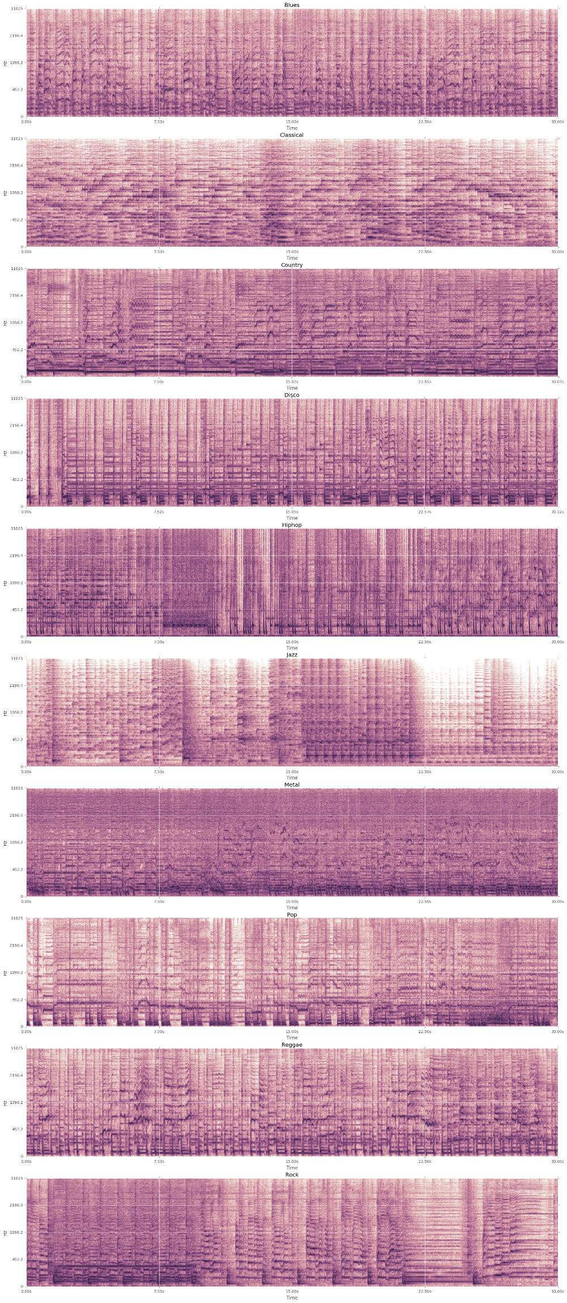

## Algorithms and Techniques:

Fourier Transform

Mel Spectrum

MFCCs

Chroma

Tonnetz

## Benchmark

Tao Feng paper on Deep learning for music genre classification where he has implemented the 4 class classification model with training accuracy of 94 % and test accuracy of 61 % using restricted Boltzmann machine. Thus we aim to develop a fully 10 class classification system with some improvements.

# Methodology

## Data Pre-processing:

Feature extraction

1. MFCCs
2. Tone

## Implementation:

Workflow:

1. Extract the features and metadata from the songs.
2. Read the features and tags from the database.
3. One Hot encoding of labels
4. Start with Just Fully Connected NN and then add few hidden layers and evaluate.

Few of the architectures has been tried while changing the number of hidden layers vs the number of hidden node.

Thus, we could reach upto 68% of testing accuracy.

## Refinement

Develop a Deep Convoluted Neural Network

* 1. Convolution with strided (valid or same)
  2. Pooling (Play with different Pooling Techniques)
  3. Fully Connected Layer

# Results

## Model Evaluation and Validation

Classification Accuracy

Confusion Matrix

# Conclusions